Handheld Oscilloscopes

THS3000 Series Datasheet

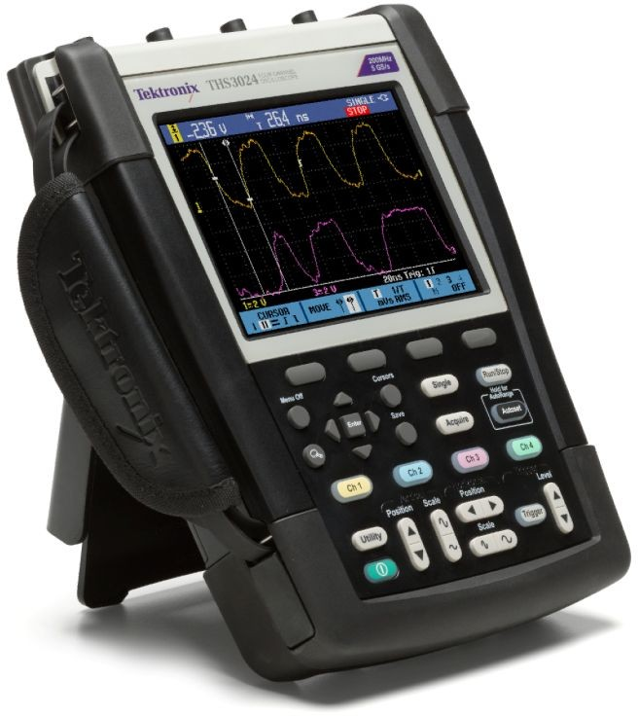
Waveform pass/fail limit testing Automatic 100 display screens recorder 6 in. (153 mm) bright color display
USB device and host support 1
7 hours of continuous battery operation

Applications
Embedded analog and digital design
Power devices, power electronics, and power supply design Automotive and avionics design and maintenance
Industrial equipment design and installation Field test and service

With four isolated channels and up to seven hours of battery life, the lightweight THS3000 Handheld Oscilloscope Series enables you to safely make floating or differential measurements on your bench or in the field. Now you can tackle tough environments with the performance you expect from Tektronix - safely and affordably.

Key performance specifications
100 MHz or 200 MHz bandwidth models
Maximum sample rates up to 5 GS/s and 200 ps resolution 4 fully isolated and floating channels
600 V_{rms} CAT III, 1000 V_{rms} CAT II rated inputs (BNC to earth ground)

Key features
21 automatic measurements
Waveform math and FFT spectral analysis
Volts, time, frequency, watts cursor measurements Measurement data logging with TrendPlot™
Accurately measure your signals
With up to 200 MHz bandwidth, 4 channels, and 5 GS/s maximum sample rate, no other oscilloscope offers as much bandwidth and sample rate in a portable handheld form factor. The THS3000 Handheld Oscilloscope Series has 10,000 points record length per channel, enabling you to capture more signal information at higher sample rates to clearly see signal details. For applications where it is important to measure slow-changing signals over long time periods, the THS3000 Series offers Roll mode that extends the record length to 30,000 points of signal information.
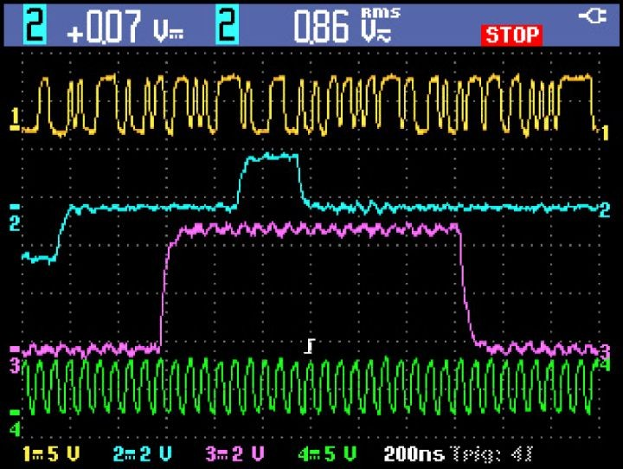
Four isolated input channels easily handle any type of mixed signal inputs

1 Maximum USB memory size supported is 2 GB

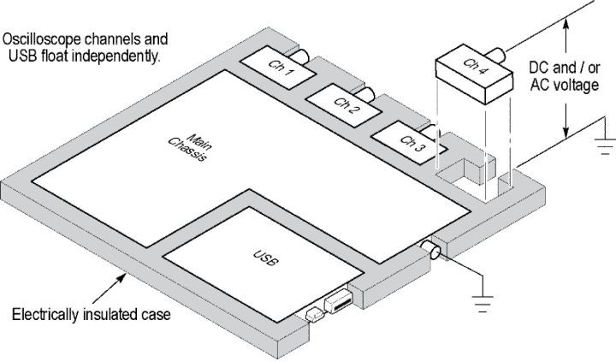
Safely make floating and differential measurements
Scope/Probe (attenuation) | Maximum safety rating |  | THS3000 viewable signal
 | Reference float safety rating | Input signal safety rating | On-screen P- P voltage | On-screen RMS voltage
THP0301 (10X) | 300 V_{rms} CAT III | 300 V_{rms} CAT III | 849 V_{p-p} | 300 V_{rms}
P5122 (100X) | 600 V_{rms} CAT II | 1000 V_{rms} CAT III | 2828 V_{p-p} | 1000 V_{rms}

Isolated-channel technology is specified to 1000 V_{RMS} maximum float voltage
Making accurate and safe measurements on power electronics, power semiconductors, and other electronics applications can be challenging when the signal reference is floating and not referenced to earth ground. When your signal ranges from low voltage to high voltage (kV) or you must use probing techniques that can potentially create ground loops, the problem is compounded.
To enable floating measurements, the THS3000 Series is architecturally different than most other oscilloscopes. All input channels are fully isolated from the main chassis and from each other. Additionally the power adapter and USB interface are fully isolated to ensure safe measurements and eliminate the risk of unintentional grounding or accidental short circuits.
When configured with the proper probes you can be assured you'll be able to make quick, safe, and accurate measurements.
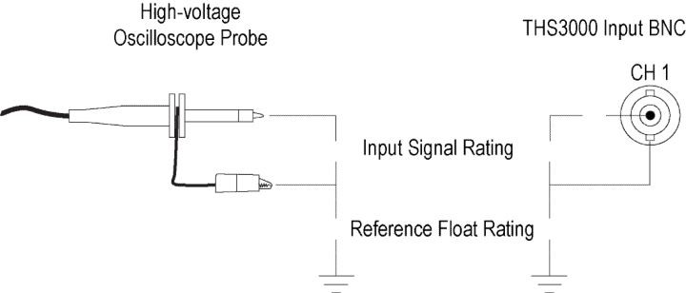
Input signal and float voltage maximum safety ratings

Selecting the right probe
Scope/Probe (attenuation) | Maximum safety rating |  | THS3000 viewable signal
 | Reference float safety rating | Input signal safety rating | On-screen P- P voltage | On-screen RMS voltage
THS3000 (1X  input) | 600 V_{rms} CAT III | 300 V_{rms} CAT III | 800 V_{p-p} | 282 V_{rms}
 | 1000 V_{rms} CAT II

Fast analysis of your device
The THS3000 Handheld Oscilloscope Series is packed with analysis tools to help you validate your device's operation and identify issues quickly.
With waveform math, you can add, subtract, or multiply any of your signals to investigate instantaneous power or look at gain. Vertical and horizontal cursors allow you to look at a specific point on your waveform for accurate measurements of voltage, current, time, or frequency. With 21 automated measurements, you can make common measurements quickly and accurately. The built-in Fast Fourier Transform (FFT) function allows you to see the frequency spectrum of your signal, revealing signal interference, crosstalk, or switching noise.

Find intermittent faults with TrendPlot™
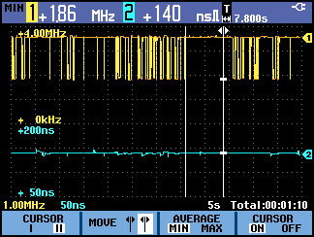
Analyze measurements and recordings visually or using measurement cursors
Intermittent faults can be caused by timing errors, temperature changes, environmental influences, or simply broken wiring or connectors. The TrendPlot™ function helps you find those faults by plotting minimum and maximum measurement values over time. You can select up to
4 measurements and plot any combination of voltages, amps, frequency, time, and phase for any or all four inputs, all with time capture information.

Automatic capture and data logging of 100 display screens
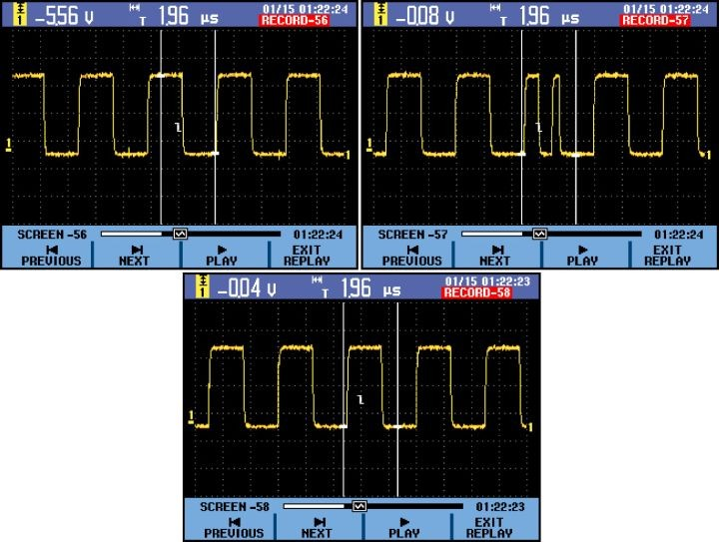
Playback of captured data is quick and easy with the THS3000 series oscilloscopes
Capturing random or changing signals can often be difficult. The THS3000 Series greatly simplifies any type of waveform data logging by continuously capturing 100 display screens. Each screen capture can include multiple channels and math waveforms, each with its own time stamp. Data capture can also be tailored to specific events by selection of qualified trigger conditions. Playback is quick and easy with the automatic replay of all captured screens or only the screens you select.

Waveform limit testing
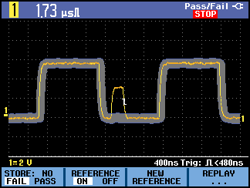
User-defined limit testing can easily identify random waveform anomalies
The THS3000 Series can automatically monitor your signals and output Pass or Fail results by judging whether the input waveform is within predefined boundaries. User selections can include testing one or all input channels and automatic recording of Pass or Fail data. Data can easily be reviewed using the Replay mode or stored externally to a USB memory device.

Complete solution for power measurements
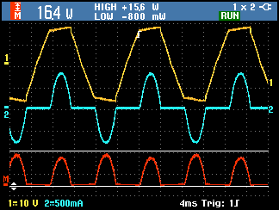
Easily calculate the instantaneous power by multiplying voltage and current waveforms
For performing power measurement on motor drives, power converters/ inverters, and power semiconductor devices the THS3000 Series is equipped to handle most common measurements. For basic debugging, the isolated input channels can be used with a variety of voltage and current probes. Each input channel can be configured to match the probe type and attenuation ensuring correct measurements and cursor readings. Four channels allow for easy measurements of three-phase power or simultaneous capture of digital control and power signals.
Measurements on power conversion electronics usually require probes with higher voltage ratings. Tektronix offers a passive probe with insulation systems specifically designed for making floating measurements. The standard THP0301-X can measure up to 849 V_{p-p} (300 V_{rms}). Optional P5122 probes, when coupled with the THS3000 Series, are suitable for making measurements on 1000 V_{rms} devices in Category II environments, with a maximum float voltage of up to 600 V_{rms} relative to earth ground.

Designed to make your work easier

Intuitive operation
The THS3000 Handheld Oscilloscope Series has a front-panel layout and an intuitive user interface which makes the instrument easy to use, reducing learning time and increasing efficiency. For initial setup or for situations where you're constantly changing connection points, the THS3000 Series has a single-button Autoset and Autorange feature which can automatically set up the trigger system and adjust vertical and/or horizontal oscilloscope settings.

Easy to use
The bright color display makes it easy for you to see the signals you're measuring. Each waveform is color coded and designed to correspond to the colors on the input probe connectors, the front-panel channel selector buttons, and the individual probes which are colored at both ends. By matching the colors during setup you'll be assured you can easily identify your waveforms.
For setup assistance user messages are available in 11 user-selectable languages including English, French, German, Spanish, Portuguese, Italian, Japanese, Simplified and Traditional Chinese, Korean, and Russian.

Flexible data transfer
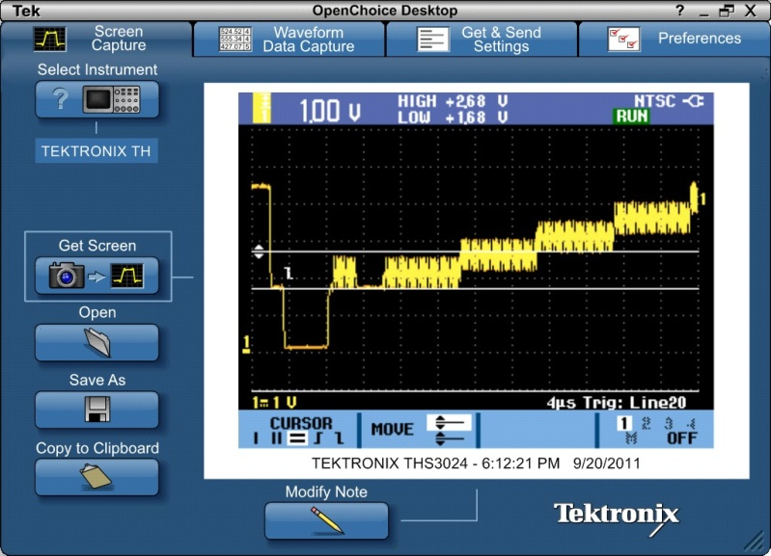
Tektronix OpenChoice® desktop software extends the capabilities of your instrument

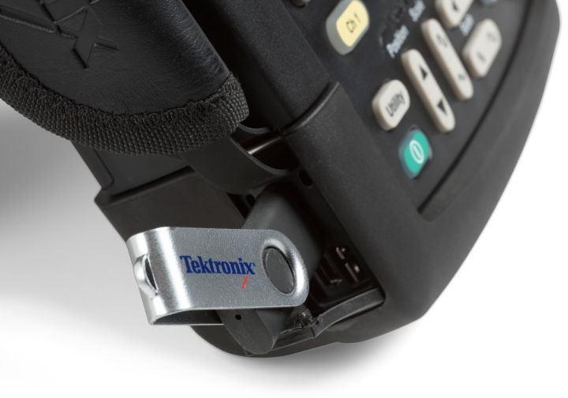
The standard USB ports facilitate data storage, data transfer, and instrument control

The THS3000 Series oscilloscopes come with both a USB host and USB mini port located on the side panel enabling you to quickly and easily save instrument settings, screenshots, and waveform data onto a flash device or transfer the data directly to a PC. The THS3000 Series oscilloscopes are shipped with the Tektronix OpenChoice® desktop software, allowing you to integrate your new THS3000 Series oscilloscope into existing measurement systems and take advantage of extended functionalities in data acquisition, measurement analysis, and documentation.

Versatility and portability for wherever your job takes you
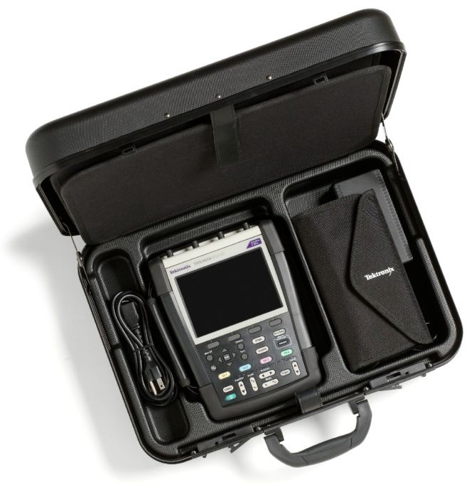
The optional travel kit (TK) version includes a hard-sided carry case for your instrument, accessories, and storage space for a laptop PC.
With a battery life of 7 hours and a weight of only 4.8 lb. (2.2 kg) the THS3000 Handheld Oscilloscope Series offers ultimate portability. Measurements taken in the lab can now be conveniently correlated with those taken in the field - all on the same instrument. Rated IP41, the THS3000 Series features the ruggedness needed to go beyond the lab and into industrial and field environments. The optional travel kit comes with a hard-sided carrying case and useful accessories allowing you to take the THS3000 Series on the road securely and conveniently. From the lab to the field, the THS3000 Handheld Oscilloscope Series offers you the versatility of using a single, high-performance instrument suitable for a wide range of working environments.

Performance you can count on
In addition to industry-leading service and support, every THS3000 Series oscilloscope comes backed with a three-year standard warranty, and ships with a Certificate of Traceable Calibration Standard.

Specifications
All specifications are guaranteed unless noted otherwise. All specifications apply to all models unless noted otherwise.

Model overview

 | THS3014 | THS3024
Isolated input channels | 4 | 4
Analog bandwidth (-3 dB) | 100 MHz | 200 MHz
Rise time | 3.5 ns | 1.7 ns
Hardware bandwidth limits | 20 kHz, 20 MHz, or full
Float voltage | 1000 V_{RMS} CAT II / 600 V_{RMS} CAT III from BNC shell to earth ground
Maximum sample rate | 2.5 GS/s (1.25 GS/s 4-ch) | 5 GS/s (1.25 GS/s 4-ch)
Maximum record length (all channels) | 10,000 points (30,000 points in roll mode (4 ms to 2 min/div))

Vertical system
Input coupling AC, DC
Input impedance 1 MΩ ±1%, 14 pF ±2 pF

Input sensitivity range 2 mV/div to 100 v/div
Vertical resolution 8 bits

DC gain accuracy ±2.1% of reading + 0.04 × range/div for 5 mV/div to 100 V/div
Max BNC input voltage (1 MΩ) 300 V_{rms} CAT III from BNC signal to BNC shell

Max probe voltage (with standard THP0301-X probe)
300 V_{rms} CAT III from 10:1 probe tip signal to BNC and reference lead

Trace positioning ±4 divisions

Horizontal system
Time base range (s/div)
THS3014 2 ns to 4 s
THS3024 1 ns to 4 s
Delay time range 1 full screen (12 divisions) of pre-trigger or up to 100 screens (1,200 divisions) of post-trigger

Timing accuracy ±100 ppm + 0.04 div
Zoom Horizontally expand or compress a live or stopped waveform

Trigger system
Input source Oscilloscope channels 1, 2, 3, or 4. All input references isolated from each other and earth ground
Main trigger modes Auto-level, Auto, Normal, and Single

Trigger coupling DC, HF reject, Noise reject (reduces sensitivity)

Trigger sensitivity, internal DC coupled
0.5 divisions from DC to 5 MHz at >5 mV/div

THS3024 1 division >5 MHz to 200 MHz
THS3014 1 division >5 MHz to 100 MHz
Trigger level range
Any channel ±4.0 divisions
Trigger modes
Edge Positive, negative, or dual slope on any input channel. Coupling includes DC, HF reject, and Noise reject
Pulse width Trigger on channel 1, width of positive or negative pulses (glitches) that are >, <, =, or ≠ a specified period of time (resolution of
0.01 div with minimum time of 50 ns)
Event Trigger on n-th occurrence of trigger (N selectable from 2 to 99)
Video Trigger on channel 1, line number, all lines, odd, even, or all fields on NTSC, PAL, PAL plus, and SECAM signals
Non-interlaced Trigger on channel 1, high-res non-interlaced video with line frequencies from 14 kHz to 65 kHz

Acquisition modes
Sample (default) Acquire sampled values
Glitch detect Captures high frequency or glitches as narrow as 8 ns from 5 μs to 120 s/div

Averaging Selectable from 2, 4, 8, or 64 waveforms
Roll Scrolls waveforms right to left across the screen at sweep speeds slower than or equal to 4 ms/div

Data recorder Automatic data logging of 100 triggered records (screens) with date and time stamp. store internally or to a USB device
Waveform compare Visually compare against user-definable reference waveforms or perform automatic pass or fail testing of 1 to 4 oscilloscope channels with data logging of test results

Automatic setup
Autoset Single-button, automatic setup of all channels for vertical, horizontal, and trigger systems
Autorange Continuous auto-setup of vertical, horizontal, and trigger systems that track signal changes

Waveform measurements
Cursors Time, freq (1/T), volts, watts, Rise/Fall time from any input channel or math waveform
Automatic measurements 21. Up to 4 can be displayed on-screen at any one time. Measurements include:
V DC, V AC_{RMS}, V AC+DC, V_{Peak} Max, V_{Peak} Min, Peak to Peak, A DC, A AC, A AC+DC, Frequency, Rise time (using cursors), Fall time (using cursors), Phase (between any 2 inputs), Positive pulse width, Negative pulse width, Positive duty cycle, Negative duty cycle, dBV, dBm into 50 Ω and 600 Ω
TrendPlot™ Records and graphically displays any 4 automatic measurements. store internally or to USB flash drive for recall and analysis

Waveform math
Arithmetic Add, subtract, and multiply waveforms
FFT Spectral magnitude. Set FFT vertical scale to Linear or Logarithmic, and FFT window to Automatic, Hamming, Hanning, or None

Display system
Display type 6 in. (153 mm) liquid-crystal color display
Display resolution 320 horizontal × 240 vertical pixels

Waveform style Vectors (dot-join), Dots, Envelope, Variable persistence, Infinite persistence
Display format YT and XY

Storage memory
Reference 4 user-definable reference traces
Waveform Stores 30 internal oscilloscope records (4 traces each) with screen image and corresponding setup

Recording Store 10 internal recordings that can be a 100-screen replay sequence, a roll-mode recording, or a TrendPlot™ measurement recording
Screen image Store up to 9 internally or 256 .bmp images to an external USB storage drive 2

Real-time clock Time and date stamp of all stored data

Input/Output ports
USB host port Supports USB mass storage devices
USB device port Mini USB-B connector allows for communication/control of oscilloscope

Probe compensator output Side-panel output
Amplitude 1.225 V_{p-p}
Frequency 500 Hz
Kensington-style lock Side-panel security slot connects to standard Kensington-style lock

2 Maximum USB memory size supported is 2 GB

Software
OpenChoice® Desktop Enables fast and easy communication between a Windows PC and the THS3000 Series. Transfer and save settings, waveforms, and screen images.

Power source
Battery 7 hour, 10.8 V rechargeable Li-Ion battery
Battery charging time 5 hours

Line power AC power adapter/charger
Power source voltage 100 V to 240 V AC ±10%

Power source frequency 50 Hz to 60 Hz

Physical characteristics
Dimensions
Height 265 mm (10.5 in.)
Width 190 mm (7.5 in.)
Depth 70 mm (2.8 in.)
Weight
Net 2.2 kg (4.8 lb.)
Shipping (base model) 4.7 kg (10.4 lb.)
Shipping (TK model) 7.8 kg (17.1 lb.)

Environmental
Enclosure IP 41 according to IEC60529S
Temperature
Operating 0 °C to +45 °C (with battery)
0 °C to +50 °C (without battery)
Nonoperating –20 °C to +60 °C
Humidity
Operating 0 °C to 10 °C, noncondensing
10 °C to 30 °C, up to 95% relative humidity 30 °C to 40 °C, up to 75% relative humidity 40 °C to 50 °C, up to 45% relative humidity
Nonoperating –20 °C to 60 °C, relative humidity, noncondensing
Altitude
Operating Up to 3,000 m (9,843 ft.)
Nonoperating Up to 12,000 m (39,370 ft.)

Environmental
Vibration/Shock
Operating Vibration (Sinusoidal): 3 g max, according to MIL-PRF-28800F, class 2 Shock: 30 g max, according to MIL-PRF-28800F, class 2
Nonoperating Vibration (Random): 0.03 g2/Hz, according to MIL-PRF-28800F, class 2
Regulatory
Electromagnetic compatibility EN 61326-1:2006, EN 61326-2-1:2006 for emission and immunity
Safety UL61010-1:2004; CAN/CSA C22.2 No. 61010.1-04; EN61010-1:2001, Pollution degree 2; ANSI/ISA-82.02.01

Ordering information

THS3000 models
THS3014 100 MHz, 2.5 GS/s, 4-channel handheld oscilloscope
THS3014-TK 100 MHz, 2.5 GS/s, 4-channel handheld oscilloscope with travel kit
THS3024 200 MHz, 5 GS/s, 4-channel handheld oscilloscope
THS3024-TK 200 MHz, 5 GS/s, 4-channel handheld oscilloscope with travel kit

All models include: THP0301-Y/B/M/G 300 MHz 10X passive probes, lithium-ion battery with 7-hour battery life, carrying handle, hanging strap, USB-A to mini USB-B cable for PC communication, Installation/Safety manual, documentation CD 3, AC power adapter with power cord, ACHHS soft-sided carry case (standard with non-TK, optional for - TK models), OpenChoice® desktop PC communication software, calibration certificate documenting traceability to national metrology institute(s) and ISO9001 quality system registration, three-year warranty.
TK models also include: hard-sided travel case (instead of soft case), soft-sided probe case, 2 probe replacement accessory kits. Please specify power plug when ordering.

Warranty
Three-year warranty covering all parts and labor, excluding probes.

Instrument options

International power plugs
Opt. A0 North America power plug (115 V, 60 Hz)
Opt. A1 Universal Euro power plug (220 V, 50 Hz)
Opt. A2 United Kingdom power plug (240 V, 50 Hz)
Opt. A3 Australia power plug (240 V, 50 Hz)
Opt. A4 North America power plug (240 V, 50 Hz)
Opt. A5 Switzerland power plug (220 V, 50 Hz)
Opt. A6 Japan power plug (100 V, 50/60 Hz)
Opt. A10 China power plug (50 Hz)
Opt. A11 India power plug (50 Hz)

3 Documentation on CD is in the following languages: English, German, Korean, Japanese, Simplified Chinese, Traditional Chinese, and Russian (063-4379-xx).

Service options
Opt. SILV400 Standard warranty extended to 5 years

Recommended accessories

Accessories

Accessory | Description
THSBAT | Additional spare battery
THSCHG | Battery charger (does not include AC power adapter)
ACHHS | Instrument soft case
HCHHS | Instrument hard case (standard with TK models)
376-0255-xx | Versatile hanging hook
020-3085-xx | Probe replacement accessory kit
119-7900-xx | AC power adapter

Probes

Probe | Description
THP0301-Y | (Yellow) 300 V, DC to 300 MHz 10X high-voltage probe 4
THP0301-B | (Blue) 300 V, DC to 300 MHz 10X high-voltage probe 4
THP0301-M | (Magenta) 300 V, DC to 300 MHz 10X high-voltage probe 4
THP0301-G | (Green) 300 V, DC to 300 MHz 10X high-voltage probe 4
A621 | 2000 A, 5 kHz to 50 kHz AC current probe/BNC
A622 | 100 A, 100 kHz AC/DC current probe/BNC
P5122 | 200 MHz passive 100X high-voltage probe
P5150 | 500 MHz passive 50X high-voltage probe 5
CT2 | 2.5 A, 200 MHz AC current probe
TCP303/TCPA300 | 150 A, 15 MHz AC/DC current probe/amplifier
TCP305A/TCPA300 | 50 A, 50 MHz AC/DC current probe/amplifier
TCP312A/TCPA300 | 30 A, 100 MHz AC/DC current probe/amplifier
TCP404XL/TCPA400 | 500 A, 2 MHz AC/DC current probe/amplifier
Tektronix is registered to ISO 9001 and ISO 14001 by SRI Quality System Registrar.

4 One probe is a standard accessory with the instrument.
5 The P5150 probe is fully compatible with THS Series oscilloscopes, but 50X vertical scaling is not offer

ASEAN / Australasia (65) 6356 3900 | Austria 00800 2255 4835* | Balkans, Israel, South Africa and other ISE Countries +41 52 675 3777
Belgium 00800 2255 4835* | Brazil +55 (11) 3759 7627 | Canada 1 800 833 9200
Central East Europe and the Baltics +41 52 675 3777 | Central Europe & Greece +41 52 675 3777 | Denmark +45 80 88 1401
Finland +41 52 675 3777 | France 00800 2255 4835* | Germany 00800 2255 4835*
Hong Kong 400 820 5835 | India 000 800 650 1835 | Italy 00800 2255 4835*
Japan 81 (3) 6714 3010 | Luxembourg +41 52 675 3777 | Mexico, Central/South America & Caribbean 52 (55) 56 04 50 90
Middle East, Asia, and North Africa +41 52 675 3777 | The Netherlands 00800 2255 4835* | Norway 800 16098
People's Republic of China 400 820 5835 | Poland +41 52 675 3777 | Portugal 80 08 12370
Republic of Korea +822 6917 5084, 822 6917 5080 | Russia & CIS +7 (495) 6647564 | South Africa +41 52 675 3777
Spain 00800 2255 4835* | Sweden 00800 2255 4835* | Switzerland 00800 2255 4835*

